

**East West University**

Department of Computer Science and Engineering

**Course Code: CSE103**

**Course Title: Structured Programming**

**Project Name: Simple Book Shop Management Program**

Submitted to:

Name: Dr. Md. Hasanul Ferdaus

Assistant Professor, CSE Department.

Submitted by:

Name:

1. Samia Rahman (2022-3-60-087)
2. Tasnia Farin Ifa (2022-3-60-096)
3. Mushfika Ema (2022-3-60-100)
4. Sheikh Sarafat Hossain (2022-3-60-109)

Group:05

Section: 11

Department: CSE

Date of Submission: 31/12/2022

**Simple Book Shop Management Program**

# Introduction:

The mini-project “Simple Book Shop Management Program” is a console program using basic C programming constructs: selection statements (if-else, switch), loops (while, for,do-while), arrays, structures (struct), and  I/O functions (printf, scanf,etc.) using the C programming concepts and techniques taught in the CSE103course. This project has been compiled in Code Blocks with the GCC compiler. In this console program, we can do basic library management tasks like adding the book, view the added book, search the books etc.

# Welcome Message:” Welcome to Simple Book Management System ”:

When the program is executed, firstly the main() function will display the head message using headMessage() function, which prints “Library Management System Project” and the welcome message using showWelcomeMessage() function which prints ”Welcome to Simple Book Management System” showing  option menu form 1 to 6 , which uses showMenuOptions() function and waits for the user to input.

**Option** **1:** **Display** **this** **menu**

When the user inputs choice 1, the main() function displays all the options for the user and again asks the user to select any choices of the book management program showing the message “Enter your choice:”

Input: 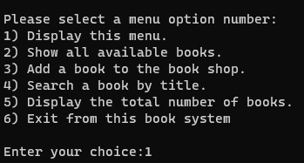

Output:

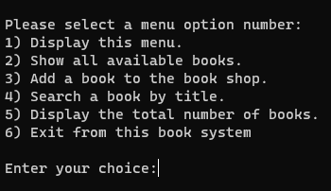

**Option 2: Show all available books**

When the user inputs choice 2, the main () function calls showBooks() function which displays all the available books in the Book management system.

Input: Output after adding books:

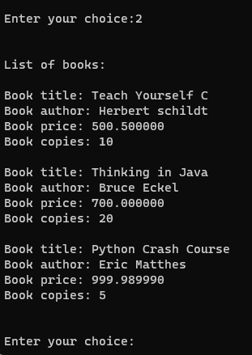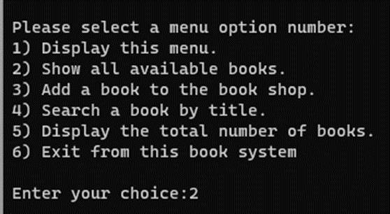

Output before adding books:

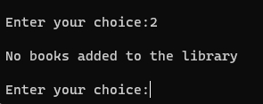

**Option** **3:** **Add** **a** **Book** **to** **the** **Bookshop:**

When the user inputs choice 3, the main () function calls addBooks() function which asks the user to input Book title, showing the message “Enter Book Title:”. After giving input to the book title, the addBooks() function asks the user to input author name, price of book and number of available copies of the particular book showing the messages “Enter Book Author:”, “Enter book price:” and “Enter Number of copies:” one by one. After adding all 4 data of the book, the addBook() function shows the message “Book added successfully!! ”.

We can add more books up to 500 by choosing option and following the previous step of adding a book.

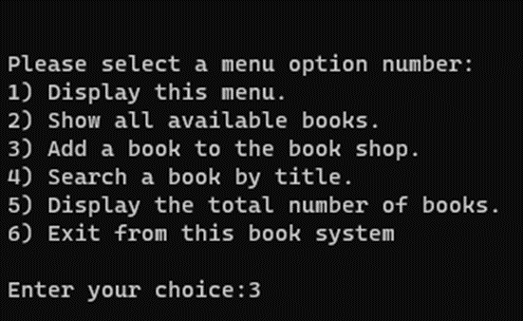Input:

Output:

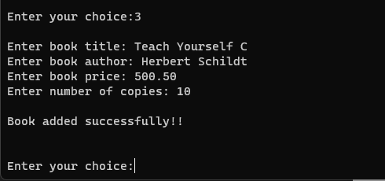

Output after adding 3 books:

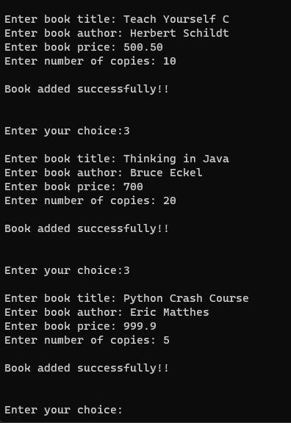

**Option** **4:** **Search** **a** **Book** **by** **Title:**

When the user inputs choice 4, the main() function calls searchBook() function which asks the user to input Book title he wants to find in the Book management system, showing the message “Enter Book Name to search :”.

Book Found:

If the entered book title by the user matches with any available books to the book management system, the searchBook() function shows all the information regarding that particular book including “Book Name”, ”Author Name”, “Book price” and “Number of copies”.

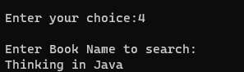Input:

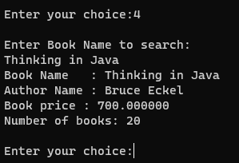Output:

Book Not Found:

If the entered book title by the user does not match with any available books to the book management system, the searchBook() function shows “Book not found message”.

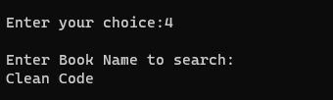Input:

Output:

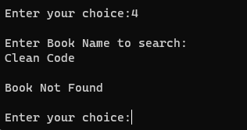

**Option 5: Display the Total Number of Books:**

When the user inputs choice 5, the main () function calls showNumberOfBooks() function which shows the total number of available books in the Book Management System. Here, we have added 4 books by using choice 3. Then when we have entered choice 5, showNumberOfBooks() function shows 4 books showing the message “Total numbet of books in the shop:”.

Input:

Output:

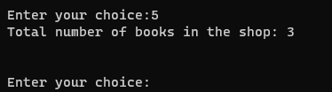

Output when bookshop is empty:

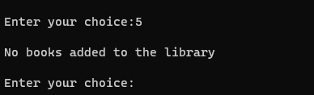

**Option** **6:** **Exit** **from** **this** **book** **system**

When the user inputs choice 6, the main () function calls showGoodByeMessage() function which terminates the program by showing the message “Thank you for using simple book management system”.

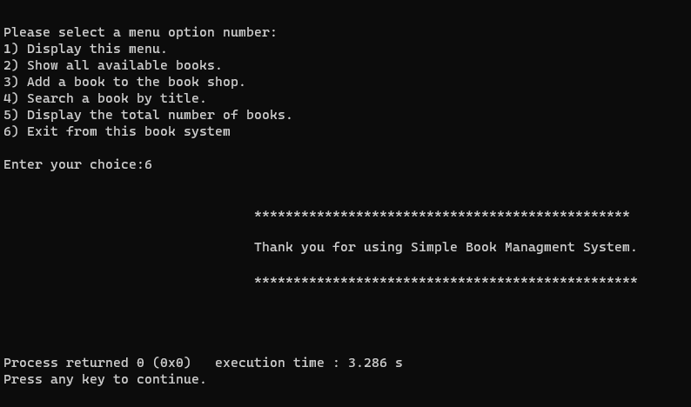

That’s how the “Simple Book Shop Management Program” works.